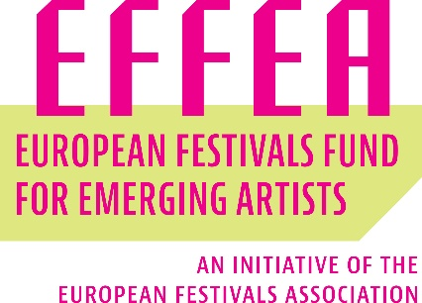

Residency letter of intent with the artist

This agreement confirms that______________________________ (leading festival) and ______________________________ (individual artist, collective, company, ensemble, group,...) commit to work together under the activities eligible for support of the grant from the European Festivals Fund for Emerging Artists – EFFEA in the category of ______________________________ (EFFEA “Discovery” or EFFEA “Springboard”).

_____________ _____________
Place and date (Signature leading festival)

__________________________
(Signature artist/ collective of artists)

