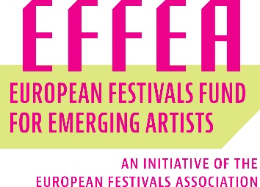

Letter of intent with at least two other partner festivals

This agreement here confirms that______________________________ (leading festival) alongside with
______________________________ (partner festival 1),
______________________________ (partner festival 2),
and optionally other partner festivals:
________________________________________________________________________,
commit to work together with _______________ (name of the artist/collective of artists) under the activities eligible for support of the grant from the European Festivals Fund for Emerging Artists - EFFEA. This partnership applies under the category of______________________________ (EFFEA “Discovery” Resident Artist / EFFEA “Springboard” Resident Artist).

_____________ _____________
Place, date (Signature leading festival)
_____________
(Signature partner festival 1)
_____________
(Signature partner festival 2)
_____________
(Signature additional partner festivals)

